**DAILY ONLINE ACTIVITIES SUMMARY**

|  |  |  |  |  |  |  |  |  |
| --- | --- | --- | --- | --- | --- | --- | --- | --- |
| **Date:** | **04/06/2020** | | | | | **Name:** | **VANDANA** | |
| **Sem & Sec** | **IV sem & B section** | | | | | **USN:** | **4AL18CS095** | |
| **Online Test Summary** | | | | | | | | |
| **Subject** | | **Microcontroller And Embedded Systems** | | | | | | |
| **Max. Marks** | | **20** | | **Score** | | | **15** | |
| **Certification Course Summary** | | | | | | | | |
| **Course** | **Introduction to Cyber Security** | | | | | | | |
| **Certificate Provider** | | | **Greatlearning academy** | | **Duration** | | | **7.0 hours** |
| **Coding Challenges** | | | | | | | | |
| **Problem Statement1:** Write a C++ program to find the missing number in array.  **Problem Statement2:** write a java program to read three integer values from the keyboard and find the sum of the values. Declare a variable "sum" of type int and store the result in it. | | | | | | | | |
| **Status: Executed** | | | | | | | | |
| **Uploaded the report in Github** | | | | | **YES** | | | |
| **If yes Repository name** | | | | | **Online-coding** | | | |
| **Uploaded the report in slack** | | | | | **YES** | | | |

Online Test Summary: 18CS44 test was scheduled from 2:00pm t0 2:30pm .The portion for the IA was 3rd module there were 30 questions and the time assigned was 30 minutes the questions were mcq type.

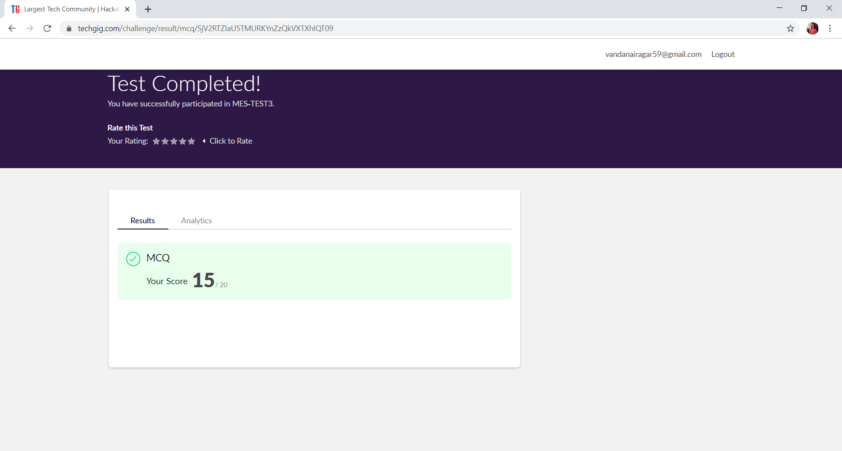

This is the snap shot of the test completed and marks obtained.

Online Certification Course Summary: Today I have opted a new course that is Introduction to Cyber Security. In today’s session I have learnt how blockchain plays its role in cyber security and also about blockchain what exactly it is and what is bitcoin and also about career and industry landscape.

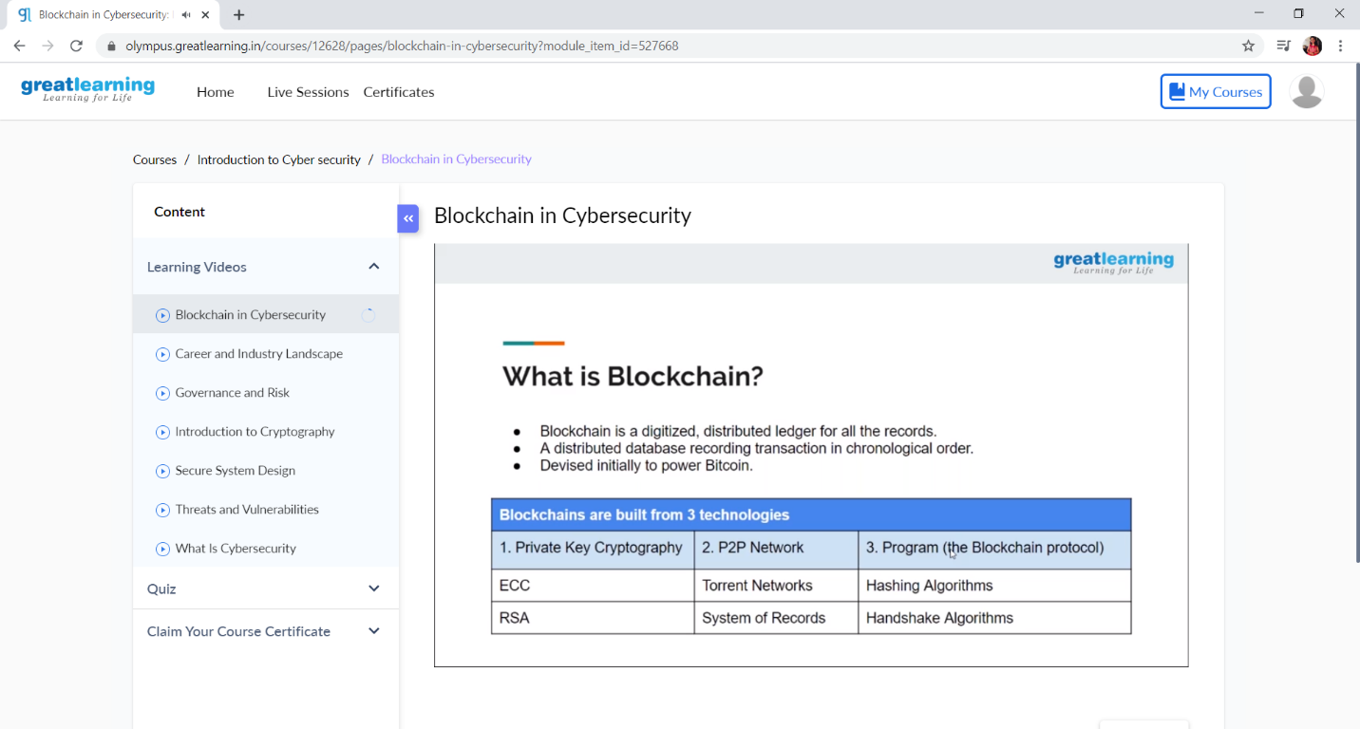



These are the snap shots of today’s sessions.

Online Coding Summary: **Today I had received one program from prof. Shilpa CSE Dept. and from Prof. Reena Lobo CSE Dept. The program is mentioned above in the coding challenges(pg.01). I have also uploaded it to my Github repository.**

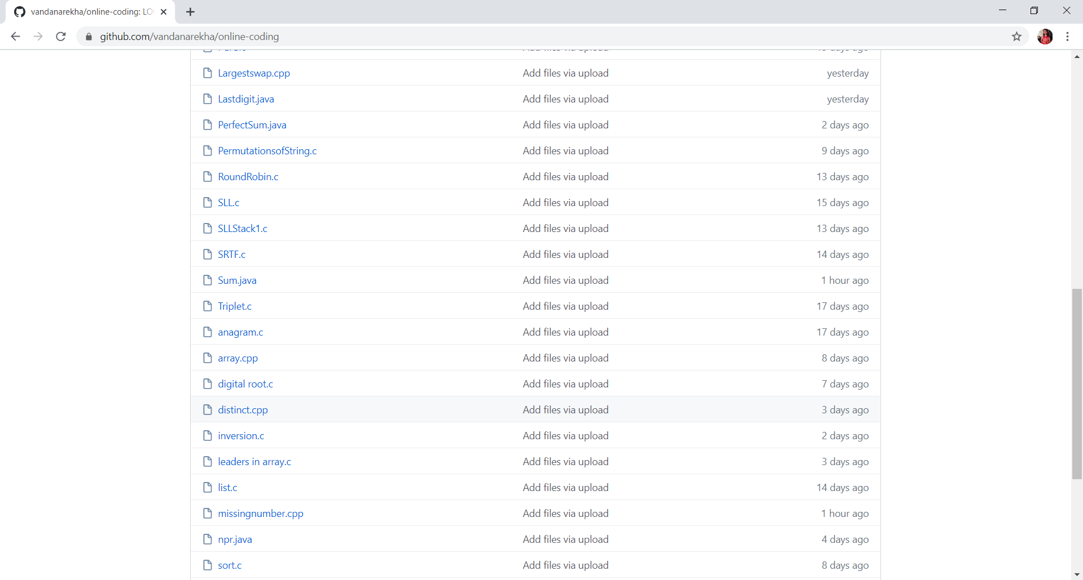

**This is the snap shot of my Github repository** were I have uploaded the code. File name is Sum.java and missingnumber.cpp